Information for Parents

Primary School

Addition

Calculations at Tonacliffe - Addition Progression

This leaflet will show you the main steps your child will go through while learning how to do addition calculations at Tonacliffe Primary School.
When children are confident and secure at a step, they will move on to the next one.

Step 1

First steps are done practically with apparatus. For example with toy dinosaurs, counters etc. It is essential that children are fully confident in adding with apparatus before they move on.

Step 2

Next, children are encouraged to develop a mental picture of the number system in their heads to use for calculation. They develop ways of recording calculations using pictures, etc.

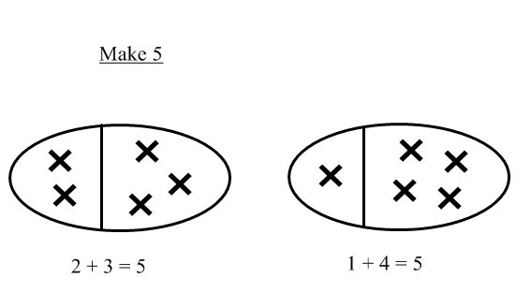

Step 3

They use numberlines and practical resources to support calculation and teachers demonstrate the use of the numberline.

3 + 2 = 5
+1
+1

___________________________________________
0 1 2 3 4 5 6 7 8 9

Children then begin to use numbered lines to support their own calculations using a numbered line to count on in ones.

+1
+1
+1
+1
+1
8 + 5 = 13
0 1 2 3 4 5 6 7 8 9 10 11 12 13 14 15

Step 4

Children will begin to use ‘empty number lines’ themselves starting with the larger number and counting on.

- First counting on in tens and ones.

34 + 23 = 57
+10
+10

+1
+1
+1

34 44 54 55 56 57

- Then helping children to become more efficient by adding the units in one jump (by using the known fact 4 + 3 = 7).

34 + 23 = 57
+10
+10

+3

34 44 54 57

- Followed by adding the tens in one jump and the units in one jump.

34 + 23 = 57
+20
+3

34 54 57

- Bridging through ten can help children become more efficient.

37 + 15 = 52
+10
+3
+2

37 47 50 52

- Count on from the largest number irrespective of the order of the calculation.

38 + 86 = 124
+30
+4
+4

86 116 120 124

- Compensation

49 + 73 = 122
+50

-1

73 122 123

Children will begin to use informal pencil and paper methods (jottings) to support, record and explain partial mental methods building on existing mental strategies.

Step 5 - Informal written methods

Adding most significant digits first, and then moving to adding least significant digits.

67 + 24 = (60 + 20) + (7 + 4)
= 80 + 11 = 91

As children become more confident this can be shortened to:

86 + 65 = 140 + 11 = 151

Moving to adding the least significant digits first in preparation for ‘carrying’.

- 267
+ 24 + 85
1 1 ( 7 + 4) 12 ( 7 + 5)
80 (60 + 20) 140 (60 + 80)
9 1 200 (200 + 0)
352

Step 6

From this, children will begin to carry below the line.

625 783 367
+ 48 + 42 + 85
673 825 452
¹ ¹ ¹ ¹

Using similar methods, children will:
- add several numbers with different numbers of digits;
- begin to add two or more three-digit sums of money, with or without adjustment from the pence to the pounds;
- know that the decimal points should line up under each other, particularly when adding mixed amounts, e.g. £3.59 + 78p.

Step 7

Children should extend the carrying method to numbers with three and four digits.

587 3587
+ 475 + 675
1062 4262
¹ ¹ ¹ ¹ ¹
Using similar methods, children will:
- add several numbers with different numbers of digits;
- begin to add two or more decimal fractions with up to three digits and the same number of decimal places;
- know that decimal points should line up under each other, particularly when adding mixed amounts, e.g. 3.2 m + 280 cm.

Step 8

Children should extend the carrying method to number with any number of digits.

58754 13587
+ 47532 + 4675
106286 18262
¹ ¹ ¹ ¹ ¹

42
6432
786
3
+ 4684
11947
¹ ² ¹

Using similar methods, children will
- add several numbers with different numbers of digits;
- begin to add two or more decimal fractions with up to four digits and either one or two decimal places;
- know that decimal points should line up under each other, particularly when adding mixed amounts, e.g. 401.2 + 26.85 + 0.71.

