Information for Parents

Primary School

Division

Calculations at Tonacliffe - Division Progression

This leaflet will show you the main steps your child will go through while learning how to do addition calculations at Tonacliffe Primary School.
When children are confident and secure at a step, they will move on to the next one.

Deriving and recalling division facts

E.g. From knowledge that 8 x 5 = 40, know that 40 ÷ 5 = 8.

Knowing division facts is a vital part of children’s mathematical knowledge.

Year 2 linked to: 2 times table
5 times table
10 times table

Year 3 linked to: 2 times table
3 times table
4 times table
5 times table
8 times table
10 times table

Year 4 Derive and recall all division facts for all tables up to 12 x 12

Years 5 & 6 Derive and recall quickly division facts for all tables up to
12 x 12.

Step 1

Children will understand equal groups and share items out in play and problem solving. They will count in 2s and 10s and later in 5s.
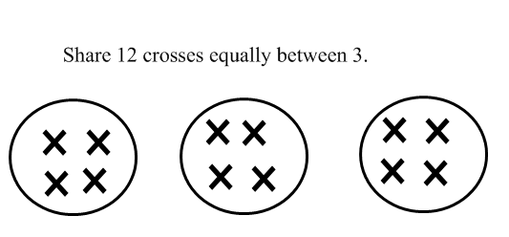

Step 2

Children will develop their understanding of division and use jottings to support calculation

- Sharing equally

6 sweets shared between 2 people, how many do they each get?

- Grouping or repeated subtraction

There are 6 sweets, how many people can have 2 sweets each?

Step 3

- Repeated subtraction using a number line or bead bar

12 ÷ 3 = 4

0 1 2 3 4 5 6 7 8 9 10 11 12

3 3 3 3

The bead bar will help children with interpreting division calculations such as 10 ÷ 5 as ‘how many 5s make 10?’

Step 4

The emphasis from Step 4 onwards is on repeated subtraction (grouping) rather than sharing.

Children will continue to use:

- Repeated subtraction using a diagram

18 ÷ 3 = 6
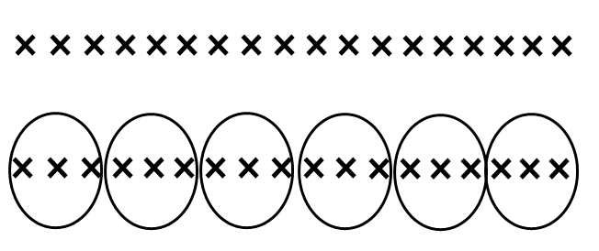
- Repeated subtraction using a number line

Children will use an empty number line to support their calculation.

24 ÷ 4 = 6

0 4 8 12 16 20 24

Step 5

Children will move onto calculations involving remainders.

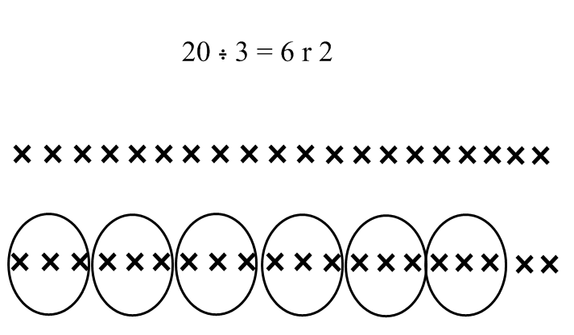

13 ÷ 4 = 3 r 1

4 4 4

0 1 5 9 13

Step 6

Children will develop their use of repeated subtraction to be able to subtract multiples of the divisor. Initially, these should be multiples of 10s, 5s and 2s – numbers with which the children are familiar.

72 ÷ 5

-50
-5
-5
-5
-5

_______________________________________________________
10
1
1
1
1
0 2 7 12 17 22 72

Step 7

Vertical method of repeated subtraction:

Short division TU ÷ U

72 ÷ 3

72
- 30 10x
42
- 30 10x
12
- 6 2x
6
- 6 2x
0

Answer = 24

Leading to subtraction of other multiples.

96 ÷ 6

96
- 60 10x
36
- 36 6x
0

Answer = 16

Step 8

At this step calculations may involve remainders.

98 ÷ 6

98
- 60 10x
38
- 36 6x
2

Answer = 16 r2

Children need to be able to decide what to do after division and round up or down accordingly. They should make sensible decisions about rounding up or down after division. For example 62 ÷ 8 is 7 remainder 6, but whether the answer should be rounded up to 8 or rounded down to 7 depends on the context.

e.g. I have 62p. Sweets are 8p each. How many can I buy?
Answer: 7 (the remaining 6p is not enough to buy another sweet)

Apples are packed into boxes of 8. There are 62 apples. How many boxes are needed?
Answer: 8 (the remaining 6 apples still need to be placed into a box)

Step 9

Children will be introduced to the standard method of short division – as this is a quicker method.

Short division – Standard method

96 ÷ 6 = 16 944 ÷ 4 = 236
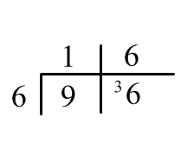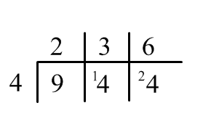

919 ÷ 7 = 131 r2
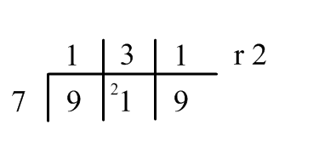

The vertical lines are important as they help children with maintaining place value in questions such as:

780 ÷ 6 = 130 784 ÷ 6 = 130 r4
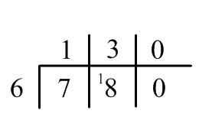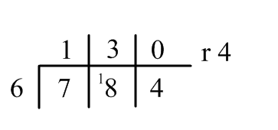

Step 10

Long division HTU ÷ TU by repeated subtraction method

828 ÷ 36

828
- 360 10x
468
- 360 10x
- 108
- 36 1x
72
- 36 1x
36
- 36 1x
0

Answer = 23

Step 11

As children become more confident this can be shortened by subtracting bigger groups.

972 ÷ 36

972
- 720 20x
252
- 252 7x
0

Answer = 27

Step 12

Division of Decimals

Extend to decimals with up to two decimal places. Children should know that decimal points line up under each other.

87.5 ÷ 7 = 12.5
